Sprint 2 Plan

Web Audio Editor

***Sprint 2.0. 17 July, 2017***

***Document Revision v1.0. 12 July, 2017***

Team 5

CMPS115-01

Dan Suh, Hyejin Lee, Minkyu Yun, Seungchyul Shin, Sunjae Lee

## Goal

Build fundamental audio editing functionalities:

1) cut & paste

2) Fade in & out

3) change volume

4) separate track

5) zoom in & out waveform

## Task listing, organized by user story

### User Story 1

*As a user, I want to click and drag over the waveform so that I can select and perform actions on parts of the waveform loaded on tracks.*

Task 1: Make it possible to click & drag in each track (1 hour)

Task 2: Visually show the area that is selected in waveform (2 hours)

Total for user story 1 : 3 hours

### User Story 2

*As a user, I want to cut and paste my audio files*

Task 1: Add buttons for cut & paste (1 hour)

Task 2: Give UI feedback that visually shows user that audio file has been copied or cut successfully (1 hour)

Task 3: Develop logic (javascript) for cut & paste (2 hours)

Task 4: Change pasted track’s waveform (add to the track and load again) (1 hour)

Total for user story 2 : 5 hours

### User Story 3

*As a user, I want to fade in and fade out my audio files*

Task 1: Add buttons for fade in & out (1 hour)

Task 2: Develop logic (javascript, open source) for fade in & out (3 hours)

Task 3: Change the waveform visualization (1 hour)

Total for user story 3 : 5 hours

### User Story 4

*As a user, I want to change volume, pitch, and speed of my audio files*

Task 1: Add meters for changing volume, pitch and speed of audio files (1 hour)

Task 2: Change volume, pitch and speed when meters changed (3 hours)

Task 3: For each track, add a side scroll for independent volume change (1 hour)

Task 4: Change volume for each track when side scroll moved (1 hour)

Total for user story 4: 6 hours

### User Story 5

*As a user, I want to selectively listen to tracks*

Task 1 : For each track, add an add on & off button to turn the track on and off (1 hour)

Task 2: When on, play the track; when off, turn off the track (2 hours)

Total for user story 5 : 3 hours

### User Story 6

*As a user, I want to zoom in and out of my audio waveforms*

Task 1 : Add buttons for zoom in and zoom out. (2 hours)

Task 2: Develop logic for zoom in and zoom out on waveforms. (1 hour)

Task 3: Apply zoom in and out separately for traks. (2 hours)

Total for user story 6 : 5 hours

## Team roles

**Dan Suh** Product Owner, Developer

**Hyejin Lee** Developer

**Minkyu Yun** Scrum Master, Developer

**Seungchyul Shin** Developer

**Sunjae Lee** Developer

## Initial task assignment

**Dan Suh** User Story 1, Task 1

**Hyejin Lee** User Story 2, Task 1

**Minkyu Yun** User Story 3, Task 1

**Seungchyul Shin** User Story 4, Task 1

**Sunjae Lee** User Story 5, Task 1

## Initial burnup chart

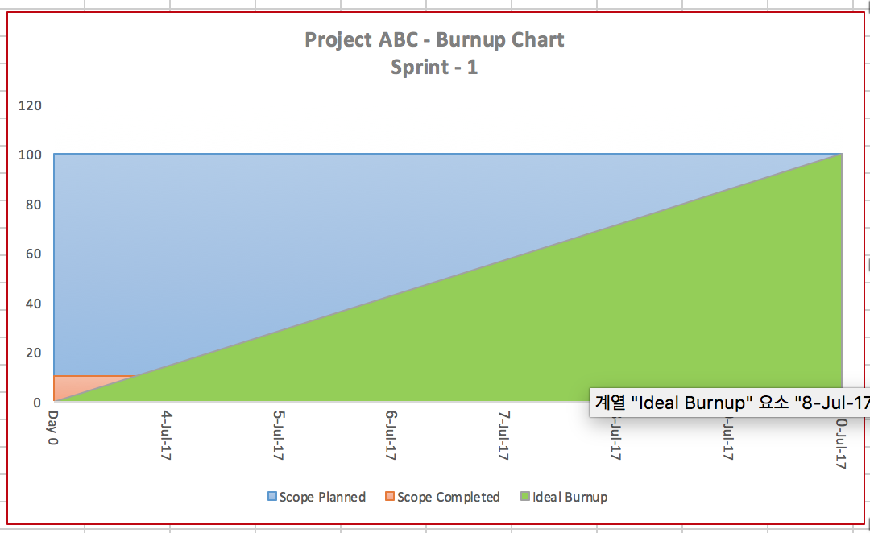

## Initial scrum board

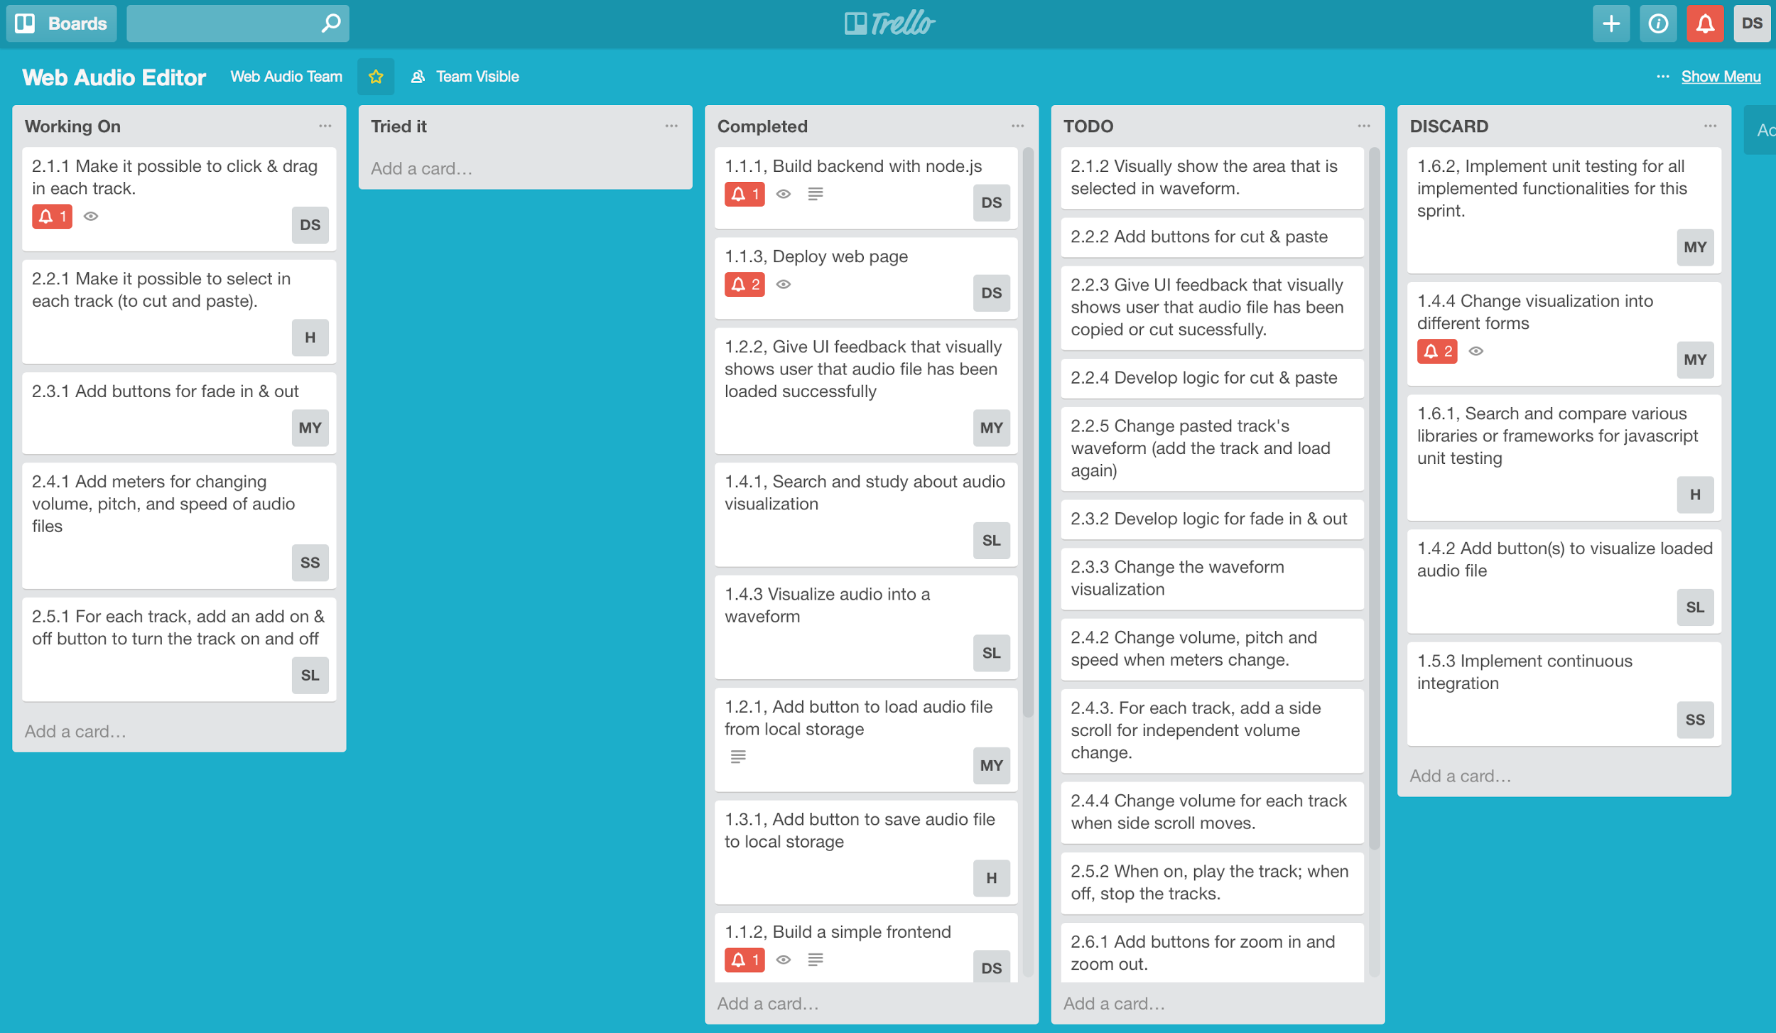

## Scrum times

**Monday** 14:20 ~ 14:40 (TA)

**Wednesday** 14:20 ~ 14:40 (TA)

**Saturday** 08:45 ~ 09:00